AMCP Fundraising Order Form
Name: _____________________________ ID# _____________________________
Phone: __________________________ Circle One: 1st Year 2nd Year
E-mail: _____________________________

Unisex Tanks $15 ea. (Black tank with sky blue font OR White tank with Sky Blue font) X____ for $15 each. (Total = $_____)
Payment type:
[ ] Cash
[ ] Check (Payable to: AMCP-Pacific)

Check #: ________________

Please return order forms
to any AMCP E-Board by Wednesday, July 2nd.

Questions? Ask
Julia Fedorova: j_fedorova@u.pacific.edu
Tiffany Wong: t_wong7@u.pacific.edu
Size | Tank Qty | Black or White
Small |  |  | 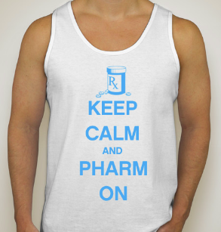
Medium
Large
X-Large
2X-Large
AMCP Fundraising Order Form
Name: _____________________________ ID# _____________________________
Phone: __________________________ Circle One: 1st Year 2nd Year
E-mail: _____________________________

Unisex Tanks $15 ea. (Black tank with sky blue font OR White tank with Sky Blue font) X____ for $15 each. (Total = $_____)
Payment type:
[ ] Cash
[ ] Check (Payable to: AMCP-Pacific)

Check #: ________________

Please return order forms
to any AMCP E-Board by Wednesday, July 2nd.

Questions? Ask
Julia Fedorova: j_fedorova@u.pacific.edu
Tiffany Wong: t_wong7@u.pacific.edu
Size | Tank Qty. | Black or White
Small
Medium
Large
X-Large
2X-Large

