AMCP’s Script Your Future  LOLLICUP  Monday November 3, 2014  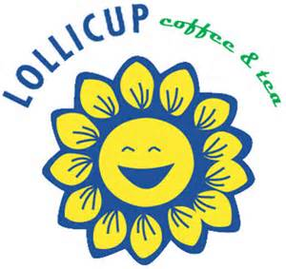  2233 Grand Canal Blvd, #204a  Please Bring this Flyer and Lollicup will donate 20% of your purchase  Applies to drinks only.  THANK YOU!!! | AMCP’s Script Your Future  LOLLICUP  Monday November 3, 2014  2233 Grand Canal Blvd, #204a  Please Bring this Flyer and Lollicup will donate 20% of your purchase  Applies to drinks only.  THANK YOU!!!
AMCP’s Script Your Future  LOLLICUP  Monday November 3, 2014  2233 Grand Canal Blvd, #204a  Please Bring this Flyer and Lollicup will donate 20% of your purchase  Applies to drinks only.  THANK YOU!!! | AMCP’s Script Your Future  LOLLICUP  Monday November 3, 2014  2233 Grand Canal Blvd, #204a  Please Bring this Flyer and Lollicup will donate 20% of your purchase  Applies to drinks only.  THANK YOU!!!

